1. Text

   Description automatically generated
2. Here Order class will be our main/context class and we will represent the state of the Order class using State Design Pattern.
3. So, each state of an order is going to be a separate class in this pattern.
4. Graphical user interface, application, Word

   Description automatically generated
5. We are going to see different workflow when Order.cancel() happens.
6. Graphical user interface, text, application

   Description automatically generated
   1. This interface represents abstract order state.
   2. Multiple implementations of this interface represent the state of an Order.
7. Text

   Description automatically generated with medium confidence
8. if the following slide with many windows is not clear then no issue. I have put each individual slides next to this one.
9. 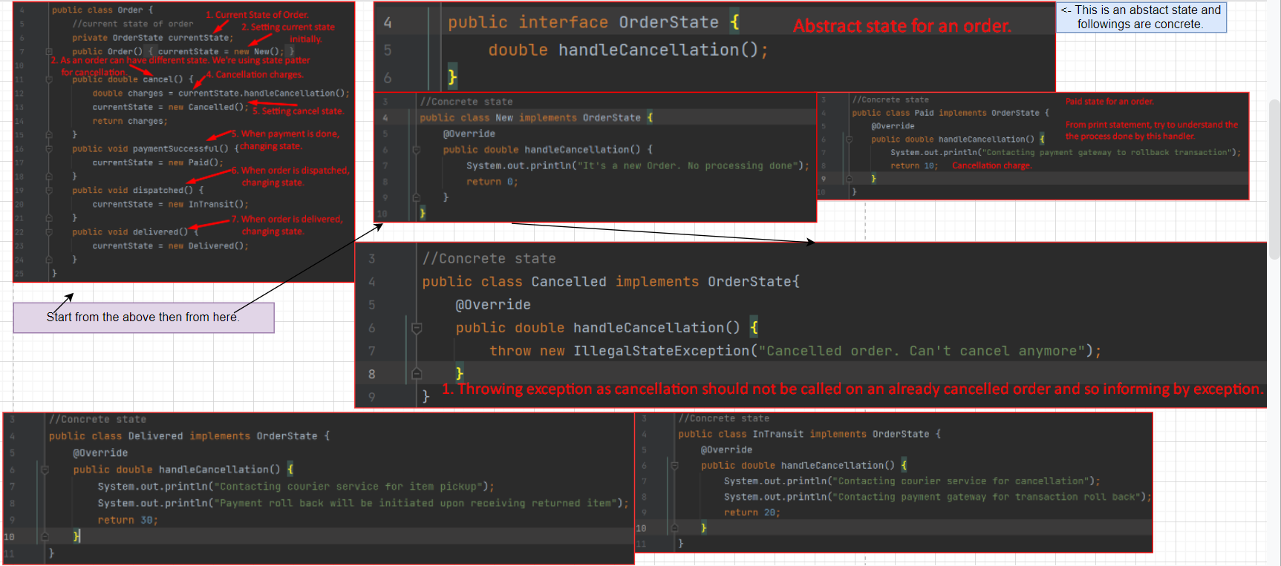Individual Slide starts from here.  
   **Order.java**: Whose state will be maintained using State Design Pattern.  
   Text

   Description automatically generated  
    **OrderState.java**: Abstract State.  
   Graphical user interface, text, application

   Description automatically generated  
   **Concrete State**:  
   Text

   Description automatically generatedGraphical user interface, text

   Description automatically generated  
   Text

   Description automatically generated  
   Text

   Description automatically generated  
   Graphical user interface, text, website

   Description automatically generated
10. Graphical user interface

    Description automatically generated